CHAPTER 1
INTRODUCTION
  - Overview
The rapid growth of digital technology, online services, and internet-based communication has significantly increased cybersecurity threats across the world. Cyberattacks such as phishing scams, credential leaks, ransomware, and data breaches are affecting individuals, organizations, and government agencies on a daily basis.. Therefore, there is a strong need for an intelligent and proactive cybersecurity solution capable of monitoring threats in real time and preventing attacks before compromise.
The proposed project, “BreachShield: AI Powered OSINT Breach Detection & Dark Web,” is designed to provide a comprehensive cybersecurity platform using Open-Source Intelligence (OSINT), Artificial Intelligence (AI), blockchain technology, cloud computing, and browser-based security systems.
The platform continuously scans breach databases, phishing feeds, malicious domains, and dark web sources to identify leaked credentials and suspicious activities in real time. The system uses OSINT-based monitoring techniques to collect cybersecurity threat information from publicly available sources such as breach repositories, phishing databases, security APIs, and dark web intelligence feeds. APIs such as VirusTotal and PhishTank are integrated into the system to improve threat detection and analysis. The collected data is continuously monitored and processed to identify potential cybersecurity risks affecting users and organizations.

  - Motivation
The rapid increase in cyberattacks, phishing scams, credential leaks, and dark web activities has created serious cybersecurity challenges for individuals and organizations. Users often become victims of cybercrime because existing security systems mainly provide reactive protection after damage has already occurred. Millions of sensitive credentials and personal records are leaked through breach databases and dark web forums every year, causing financial loss, identity theft, and privacy violations. The lack of real-time monitoring and early threat detection increases the risk of cyberattacks and reduces user trust in digital platforms. In many cases, users remain unaware that their accounts or personal information have been compromised until suspicious activities or financial fraud take place. Traditional cybersecurity tools usually focus on individual functions such as antivirus protection, phishing detection, or vulnerability scanning, but they lack a unified and intelligent system capable of providing proactive cybersecurity defense. The advancement of technologies such as Artificial Intelligence (AI), Open-Source Intelligence (OSINT), blockchain, and cloud computing creates opportunities to develop smarter and more efficient cybersecurity solutions. The motivation behind this project is to develop an intelligent and automated cybersecurity platform that provides real-time breach monitoring, dark web surveillance, phishing prevention, vulnerability scanning, and secure blockchain-based reporting. The system aims to improve digital security, protect user privacy, reduce cyber risks, and provide proactive threat detection before damage occurs. By integrating AI-driven analysis, browser-based protection, cloud infrastructure, and tamper-proof blockchain logging, the proposed solution contributes toward building a safer and more secure digital environment for users and organizations.

  - Objective
The primary objective of this project is to develop an AI-powered cybersecurity platform capable of providing real-time breach detection, dark web monitoring, phishing prevention, vulnerability analysis, and secure blockchain-based threat reporting. The specific objectives are:
- To study existing cybersecurity monitoring and breach detection systems.
- To collect cybersecurity threat information from OSINT databases, phishing feeds, and dark web sources.
- To implement real-time breach monitoring and phishing detection.
- To develop AI-based risk analysis and malicious URL classification models.
- To provide browser extension alerts and proactive phishing prevention. To implement vulnerability scanning for websites and applications.
- To ensure user privacy and data security using authentication and encryption techniques.
- To ensure user privacy and data security using authentication and encryption techniques.
- To design a user-friendly dashboard for monitoring cybersecurity threats and breach reports.
- To ensure scalability, reliability, and secure cloud-based threat monitoring
  - Scope
The scope of the proposed project involves the design and implementation of an intelligent cybersecurity platform capable of continuously monitoring cyber threats, detecting leaked credentials, preventing phishing attacks, and identifying vulnerabilities in websites and applications. The system is intended for use by individuals, organizations, educational institutions, and cybersecurity professionals where digital security and privacy protection are essential. It integrates OSINT-based threat intelligence, AI-assisted phishing detection, browser protection mechanisms, blockchain logging, and cloud-based monitoring into a single unified framework. The project includes real-time monitoring of breach databases, dark web sources, phishing feeds, and malicious domains. The collected cybersecurity data is analyzed using AI and machine learning algorithms to identify abnormal patterns, suspicious URLs, and possible cyber threats. The system generates real-time alerts and notifications whenever security risks or leaked credentials are detected. The proposed framework is modular and scalable, allowing future integration of advanced AI models, additional threat intelligence sources, and cloud-based cybersecurity services. However, the current implementation is limited to a prototype-level system using selected cybersecurity APIs, publicly available breach datasets, phishing databases, and browser-based protection mechanisms
  - Existing System
Existing cybersecurity systems mainly focus on standalone protection mechanisms such as antivirus software, phishing detection tools, vulnerability scanners, or breach notification services. Although these systems provide basic cybersecurity support, they have several limitations in terms of integration, intelligence, scalability, and proactive protection.
In traditional cybersecurity systems, users generally receive alerts only after data breaches or phishing attacks have already occurred. Most systems depend on manual security checks or isolated threat intelligence feeds without centralized real-time monitoring. Users must separately use different tools for breach checking, phishing protection, vulnerability analysis, and dark web monitoring.
Most existing systems lack intelligent AI-based risk analysis and predictive cybersecurity mechanisms. Conventional security tools mainly display threat information without providing automated analysis, phishing prediction, or proactive attack prevention.
This increases user dependency on manual interpretation and delays cybersecurity response. Another major limitation of existing cybersecurity systems is the absence of secure and tamper proof evidence management. Many systems store sensitive cybersecurity logs and breach information in centralized databases, making them vulnerable to unauthorized modification and cyberattacks.
Existing platforms also face privacy and security challenges. Sensitive user information transmitted through insecure communication channels may be exposed to attackers, resulting in privacy violations and identity theft. In addition, most systems lack integrated browser-level phishing protection and real-time dark web intelligence monitoring. Furthermore, traditional cybersecurity solutions are often fragmented, less scalable, and difficult to integrate with modern cloud technologies and AI-driven analysis systems.
These limitations create the need for a more intelligent, integrated, and secure cybersecurity platform.
1.6 Proposed System
The proposed system is an AI-powered cybersecurity platform designed to provide real-time breach monitoring, phishing prevention, dark web surveillance, vulnerability scanning, and secure blockchain-based cybersecurity reporting. The system integrates OSINT monitoring, Artificial Intelligence, cloud computing, browser protection mechanisms, and blockchain technology into a single unified framework.
In the proposed architecture, cybersecurity threat data is continuously collected from breach databases, phishing feeds, dark web sources, malicious domains, and public cybersecurity APIs. The collected data is securely transmitted to cloud-based servers where it is processed and analyzed in real time. Users can access cybersecurity alerts, breach reports, and vulnerability analysis through web dashboards, mobile applications, and browser extensions. The system incorporates AI-based phishing detection and risk analysis using machine learning algorithms. The collected threat data is preprocessed and analyzed to identify malicious websites, suspicious URLs, and abnormal cybersecurity patterns. The AI module assists users by generating risk scores, threat predictions, and real-time phishing alerts.
To ensure data protection and system reliability, the proposed framework implements multiple cybersecurity measures. These include encrypted communication, secure OTP-based authentication, role-based access control, blockchain-based audit logging, and secure cloud storage. These features help maintain confidentiality, integrity, and availability of sensitive cybersecurity information
The proposed system offers several advantages over traditional cybersecurity platforms:
- Real-time Real-time breach monitoring
- AI-assisted phishing detection and prevention
- Continuous dark web surveillance
- Browser-based malicious website protection
- Vulnerability scanning and security analysis
- Blockchain-based tamper-proof logging
CHAPTER-2
PROBLEM STATEMENT
2.1 Problem Statement
The rapid increase in cyberattacks, phishing scams, credential leaks, ransomware attacks, and dark web exposure has created serious cybersecurity challenges for individuals and organizations. Traditional cybersecurity systems mainly depend on isolated security tools and reactive protection mechanisms. In many cases, users become aware of cyber threats only after financial loss, account compromise, or data theft has already occurred.
Existing cybersecurity systems often lack real-time breach monitoring, intelligent phishing detection, centralized threat analysis, and secure evidence management. Most systems only provide basic threat alerts without proactive prevention or predictive cybersecurity analysis. In addition, the increasing use of cloud platforms, online services, and internet-based applications introduces cybersecurity risks such as unauthorized access, data breaches, identity theft, and malicious website attacks.
There is a need for an intelligent, secure, and scalable cybersecurity platform capable of continuously monitoring cyber threats, analyzing malicious activities in real time, detecting phishing attacks, and securely managing cybersecurity logs and breach evidence. Therefore, this project proposes “BreachShield OSINT Breach Finder Real-Time Dark Web Monitoring AI Breach Prevention Vulnerability Protection” using OSINT, Artificial Intelligence, blockchain technology, and cloud-based cybersecurity mechanisms to improve digital security and proactive cyber defense.

2.2 Motivation
The motivation behind this project is the growing demand for intelligent cybersecurity systems capable of protecting users against modern cyber threats. In today’s digital environment, phishing attacks, credential leaks, malicious websites, and data breaches are increasing rapidly.
Existing security tools mainly provide reactive protection and often fail to identify cyber threats before damage occurs. Advancements in Artificial Intelligence (AI), Open-Source Intelligence (OSINT), cloud computing, and blockchain technologies provide opportunities to develop intelligent cybersecurity platforms capable of continuous monitoring and automated threat analysis. AI based systems can help identify malicious patterns, classify phishing websites, and generate proactive security alerts before users become victims of cyber
Another major motivation is the increasing importance of user privacy and secure data handling. Since cybersecurity information and breach reports contain sensitive user data, it is necessary to implement secure authentication, encrypted communication, and tamper-proof blockchain logging mechanisms to ensure privacy and system reliability.
This project aims to combine AI, OSINT, blockchain, browser protection, and cloud-based monitoring into a single integrated cybersecurity platform to create a secure, efficient, and intelligent threat monitoring system suitable for modern digital environments.

2.3 Objectives
The main objective of this project is to develop an AI-powered cybersecurity platform capable of providing real-time breach monitoring, phishing prevention, dark web surveillance, vulnerability analysis, and secure blockchain-based threat reporting.
- To study existing cybersecurity monitoring and phishing detection systems.
- To collect cybersecurity threat information using OSINT databases and APIs.
- To implement real-time breach monitoring and dark web surveillance.
- To develop machine learning models for phishing detection and cyber risk analysis.
- To provide browser extension alerts and proactive malicious website protection.
- To implement vulnerability scanning for websites and applications.
- To ensure secure user authentication, encrypted communication, and privacy protection.
- To integrate blockchain technology for tamper-proof cybersecurity logging.
- To design a centralized dashboard for cybersecurity monitoring and breach management.
- To ensure scalability, reliability, and cloud-based cybersecurity support.

CHAPTER-3
DETAILED SURVEY
[1] Phishing Detection Systems: A Comprehensive Survey of Deep Learning-Based Approaches — A. K. Jain and B. B. Gupta (2024)
This paper presents a comprehensive study of deep learning techniques used for phishing detection systems. The authors discuss various neural network architectures, feature extraction methods, and classification algorithms used to identify phishing websites and malicious URLs. The survey highlights the importance of automated threat detection systems in modern cybersecurity environments. From this paper, we understood how deep learning can improve phishing detection accuracy and enhance proactive cybersecurity monitoring in our proposed BreachShield system.

[2] BreachShield: A Novel Framework for Real-Time Data Breach Detection Using OSINT and Dark Web Monitoring — S. S. Tyagi (2025)
This paper introduces a real-time cybersecurity monitoring framework that utilizes OSINT and dark web intelligence for detecting credential leaks and cyber threats. The framework continuously monitors breach databases and suspicious online activities to generate security alerts. From this paper, we understood the importance of integrating OSINT-based intelligence gathering and dark web monitoring into our project for proactive threat identification and breach prevention.

[3] An Ensemble Learning Approach for Phishing Website Detection using Hybrid Features — M. Al-Sarem, F. Saeed, and W. Boulila (2024)
This research proposes an ensemble learning model for phishing website detection using hybrid URL and content-based features. Multiple machine learning algorithms are combined to improve classification performance and detection reliability. The paper demonstrates how hybrid feature extraction improves phishing identification accuracy. From this work, we adopted the concept of AI-based threat classification and malicious URL analysis in our cybersecurity monitoring system.
[4] Blockchain-Based Secure and Immutable Log Management System for Cloud Forensics — R. Sharma and P. Kumar (2023)
This paper focuses on implementing blockchain technology for secure and tamper-proof log management in cloud forensic systems. Blockchain ensures data integrity, immutability, and secure audit trails for cybersecurity investigations. From this paper, we understood how blockchain can enhance secure logging and audit management in our project by preventing unauthorized modification of security records and threat logs.
[5] Deep Web and Dark Web Monitoring for Threat Intelligence: A Systematic Review — T. Zhang (2024)
This paper provides a systematic review of deep web and dark web monitoring techniques used for cybersecurity threat intelligence gathering. It discusses methods for collecting leaked credentials, malware information, phishing kits, and illegal cyber activities from hidden online platforms. From this paper, we learned how dark web intelligence contributes to early cyber threat detection and inspired the dark web monitoring component in our proposed system.
[6] Addressing Class Imbalance in Phishing Detection Systems using SMOTE and Deep Learning — J. Singh and N. Kumar (2024)
This research addresses the issue of class imbalance in phishing detection datasets using SMOTE (Synthetic Minority Oversampling Technique) combined with deep learning models. The proposed approach improves phishing detection accuracy and reduces false negatives in cybersecurity systems. From this paper, we understood the significance of balanced datasets and data preprocessing techniques for improving AI-based cybersecurity analysis.
[7] Explainable AI (XAI) for Malicious URL Detection: Bridging the Gap between Accuracy and Trust — L. Wang and X. Liu (2025)
This paper explores Explainable Artificial Intelligence (XAI) techniques for malicious URL detection systems. The authors focus on improving transparency and trust in AI-based cybersecurity applications by providing understandable explanations for threat predictions. From this paper, we understood the importance of explainable AI models in helping analysts interpret threat detection results generated by our cybersecurity framework.
[8] Proactive Cyber Threat Intelligence Gathering using Automated OSINT Frameworks — K. Patel (2023)
This paper discusses automated OSINT-based threat intelligence frameworks for collecting cybersecurity information from public sources, APIs, forums, and online repositories. The framework supports proactive threat monitoring and incident response. From this paper, we adopted the concept of automated threat intelligence collection and continuous monitoring for enhancing real-time cybersecurity awareness in our project.
[9] A Survey on Blockchain-based Systems for Tamper-Proof Data Logging — D. Dasgupta and S. Roy (2024)
This survey paper reviews blockchain-based mechanisms for secure and tamper-proof data logging systems. The study highlights the role of distributed ledgers in ensuring integrity, transparency, and secure audit tracking for cybersecurity applications. From this paper, we understood how blockchain can strengthen the reliability and security of threat logs and incident records within our proposed BreachShield system.
[10] Transformer-Based Models for Detecting Phishing URLs with Limited Labeled Data — H. Chen (2025)
This paper proposes transformer-based deep learning models for phishing URL detection using limited labeled datasets. The model improves detection performance through advanced contextual feature learning and attention mechanisms. From this paper, we learned how transformer architectures can improve phishing detection efficiency and support intelligent AI-driven threat analysis in cybersecurity monitoring systems.

CHAPTER-4
SURVEY SUMMARY TABLE
SL. NO | Title of the Paper | Problem Addressed | Authors’ Approach / Method | Results
1 | AI-Driven Cybersecurity Framework for Real-Time Phishing Detection | Increasing phishing attacks and malicious websites | AI models with browser-based phishing detection | Improved phishing detection accuracy
2 | Blockchain-Based Secure Cybersecurity Logging Framework | Cybersecurity logs vulnerable to tampering | Blockchain-based immutable logging system | Secure and tamper-proof audit trails
3 | OSINT-Based Threat Intelligence and Breach Monitoring System | Lack of real-time breach monitoring | OSINT intelligence collection and API integration | Early breach detection and alerts
4 | Machine Learning-Based Malicious URL Detection System | Difficulty in identifying malicious URLs | AI and ML-based URL classification | High malicious website detection rate
5 | Dark Web Threat Monitoring and Cybercrime Intelligence Platform | Credential leaks and dark web exposure | Automated dark web monitoring with AI analysis | Improved cyber threat intelligence
6 | Browser-Based Cybersecurity Protection Framework | Real-time phishing attacks through browsers | Browser extension with AI threat detection | Enhanced online safety and phishing prevention
7 | Phishing Detection Systems: A Comprehensive Survey of Deep Learning-Based Approaches | Traditional phishing detection methods are less effective | Deep learning models such as CNN and RNN for phishing detection | Improved detection accuracy and adaptability
8 | Transformer-Based Models for Detecting Phishing URLs with Limited Labeled Data | Limited labeled phishing datasets | Transformer-based phishing URL analysis using self-attention | Better contextual understanding and detection performance
9 | Explainable AI (XAI) for Malicious URL Detection | Lack of transparency in AI cybersecurity systems | Explainable AI techniques such as SHAP and LIME | Improved user trust and interpretability
10 | Blockchain-Based Secure and Immutable Log Management System for Cloud Forensics | Cybersecurity forensic logs vulnerable to modification | Blockchain-integrated immutable forensic logging | Enhanced forensic integrity and secure audit management

Table 4.1: Survey Summary Table

CHAPTER-5
SYSTEM REQUIREMENT SPECIFICATION
5.1 Functional Requirements
Functional requirements define the major operations and services that the proposed cybersecurity platform must perform. The BreachShield system is designed to continuously monitor cybersecurity threats, analyze malicious activities intelligently, and ensure secure communication and protection for users.
- Breach Detection and Monitoring: The system must continuously monitor breach databases, phishing feeds, malicious domains, and dark web sources to identify leaked credentials and cybersecurity threats in real time.
- Real-Time Threat Analysis: The system must process and analyze cybersecurity threat data continuously using AI and machine learning techniques with minimum delay.
- AI-Based Phishing Detection: The system should implement machine learning algorithms capable of identifying phishing websites, suspicious URLs, and malicious online activities.
- Browser Extension Protection: The system must provide browser extension alerts and malicious website blocking mechanisms to protect users from phishing attacks.
- Vulnerability Scanning: The system should scan websites and applications to identify weak configurations, security loopholes, and vulnerabilities.
- Secure User Authentication: The system must provide OTP-based secure login functionality and authentication mechanisms for authorized users.
- Blockchain-Based Logging: The platform should securely store cybersecurity logs and breach evidence using blockchain technology.
- Centralized Monitoring Dashboard: The system should provide a centralized dashboard for monitoring cybersecurity alerts, breach reports, and risk analysis. Dept. of ISE, AcIT 2025 - 2026 16 Title of The Project
- Notification and Alert Generation: The system must automatically generate notifications and alerts whenever cybersecurity threats or breaches are detected.
- Secure Data Storage and Retrieval: The system should securely store user information, cybersecurity logs, and historical reports in cloud databases.
5.2 Non-functional Requirements
Non-functional requirements describe the quality attributes and performance characteristics of the proposed cybersecurity platform.
- Performance: The system should process and analyze cybersecurity threats in real time with minimal latency.
- Reliability: The platform must operate continuously without interruptions to ensure uninterrupted threat monitoring.
- Scalability: The system should support future integration of additional threat intelligence feeds, AI models, and cloud services.
- Security: The platform must ensure confidentiality, integrity, and availability of cybersecurity data using encryption and authentication mechanisms.
- Availability: The system should remain accessible to users at all times through web, mobile, and browser interfaces.
- Maintainability: The system should be modular and easy to maintain and upgrade.
- Usability: The dashboards and user interfaces should be user-friendly and easy to operate.
- Accuracy: The AI-based phishing detection and cybersecurity analysis modules should provide accurate results and reduce false alerts.
- Compatibility: The system should support integration with browsers, APIs, cloud platforms, and cybersecurity tools.
- Data Privacy: Sensitive user information and cybersecurity reports must be protected using secure privacy-preserving mechanisms.
5.3 Hardware Requirements
The proposed system requires computing hardware and networking components for implementation, deployment, and continuous cybersecurity monitoring operations.
The hardware requirements are listed below:
Component | Specification
Processor | Intel Core i5 or above
RAM | Minimum 8 GB
Storage | 256 GB SSD or above
Network | Stable Internet Connection
Device | Laptop/Desktop/Smartphone
Server/Cloud Platform | Cloud-based or Local Server
Browser Support | Chrome, Edge, Firefox
Power Backup | Continuous Power Backup
5.4 Software Requirements
The software requirements define the programming tools, operating systems, databases, and technologies required for developing and deploying the proposed cybersecurity monitoring system.
Software Component | Specification
Operating System | Windows 10/11 or Linux
Programming Languages | Python, JavaScript
Frontend Technologies | HTML, CSS, React.js
Backend Framework | Node.js / Flask / Django
Database | PostgreSQL / MongoDB
Machine Learning Libraries | TensorFlow, Scikit-learn, Pandas
APIs and Feeds | VirusTotal, PhishTank, OSINT APIs
Blockchain Platform | Ethereum / Polygon
Cloud Platform | AWS / Google Cloud / Azure
Development Tools | VS Code, Jupyter Notebook
Security Tools | SSL/TLS Encryption, Authentication Modules
Web Browser | JavaScript-based Extension

CHAPTER-6
SYSTEM DESIGN
6.1 System Design
6.1.1 System Architecture
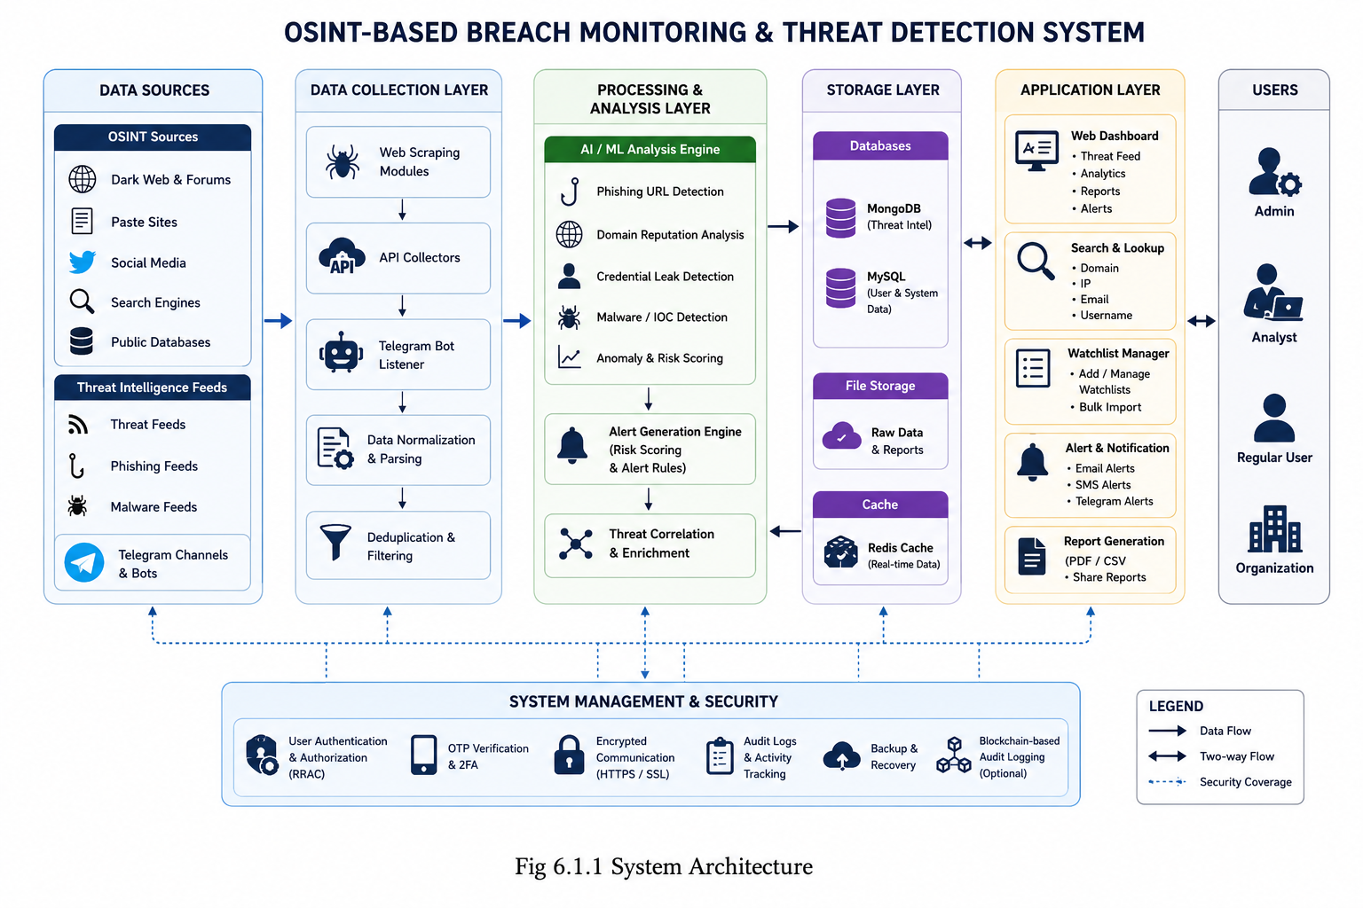
The design of the proposed system focuses on developing a secure, scalable, and intelligent cybersecurity monitoring framework using Artificial Intelligence (AI), Open-Source Intelligence (OSINT), blockchain technology, and cloud computing.. The design also emphasizes secure communication, OTP-based authentication, blockchain-backed logging, and real-time alert generation for suspicious activities. The overall framework consists of OSINT intelligence modules, AI-assisted threat analysis modules, browser protection.
Fig 6.1.1 System Architecture
- Patient/Threat Intelligence Layer (OSINT Data Source)
This layer represents the external cybersecurity intelligence sources from which raw threat information is collected. OSINT Sources: Public breach databases, phishing repositories, malware feeds, VirusTotal, PhishTank, and dark web intelligence platforms continuously provide cybersecurity threat data. Threat Data Collection: APIs and automated crawlers collect leaked credentials, malicious domains, phishing URLs, and suspicious online activities in real time.
- Data Processing Layer :
This layer processes and organizes the collected cybersecurity data before analysis. Data Cleaning and Filtering: Raw cybersecurity information is cleaned, normalized, and filtered to remove duplicate or irrelevant records. Secure Data Handling: Sensitive data is hashed and encrypted before storage and analysis to ensure privacy and security.
- AI Analysis Layer :
This layer performs intelligent cybersecurity analysis using machine learning algorithms. AI-Based Threat Detection: Machine learning models analyze suspicious URLs, phishing websites, and malicious activities. Risk Scoring and Prediction: The system generates cybersecurity risk scores and predicts possible cyber threats using AI-based analysis. Continuous Learning: AI models improve detection accuracy using threat intelligence updates and feedback mechanisms.
- Blockchain Security Layer :
This layer provides tamper-proof cybersecurity logging and secure evidence management. Blockchain Logging: Cybersecurity events, breach reports, and threat logs are securely stored using Ethereum or Polygon blockchain networks. Tamper-Proof Storage: Blockchain ensures that cybersecurity records cannot be modified or deleted by unauthorized users.
- Cloud Storage and Database Layer :
This layer securely stores cybersecurity information and user data. Cloud Databases: PostgreSQL, MongoDB, or cloud-based storage systems store breach reports, phishing alerts, and vulnerability scan results. Encrypted Storage: Sensitive cybersecurity data is encrypted before storage to improve confidentiality and privacy protection. Scalable Infrastructure: Cloud platforms support large-scale cybersecurity monitoring and real-time accessibility.
- User Interface Layer :
This layer provides interaction between users and the cybersecurity platform. Web Dashboard: Displays breach reports, cybersecurity alerts, phishing risks, and vulnerability analysis. Mobile Application: Provides real-time notifications and cybersecurity monitoring through smartphones. Browser Extension: Warns users about malicious websites and phishing attacks during internet browsing.
- Notification and Alert Layer :
This layer provides real-time cybersecurity alerts and warnings. Threat Alerts: Instant notifications are generated whenever phishing attacks, credential leaks, or suspicious activities are detected. Multi-Platform Notifications: Alerts are sent through browser extensions, mobile applications, and email systems

6.1.2 Module Design
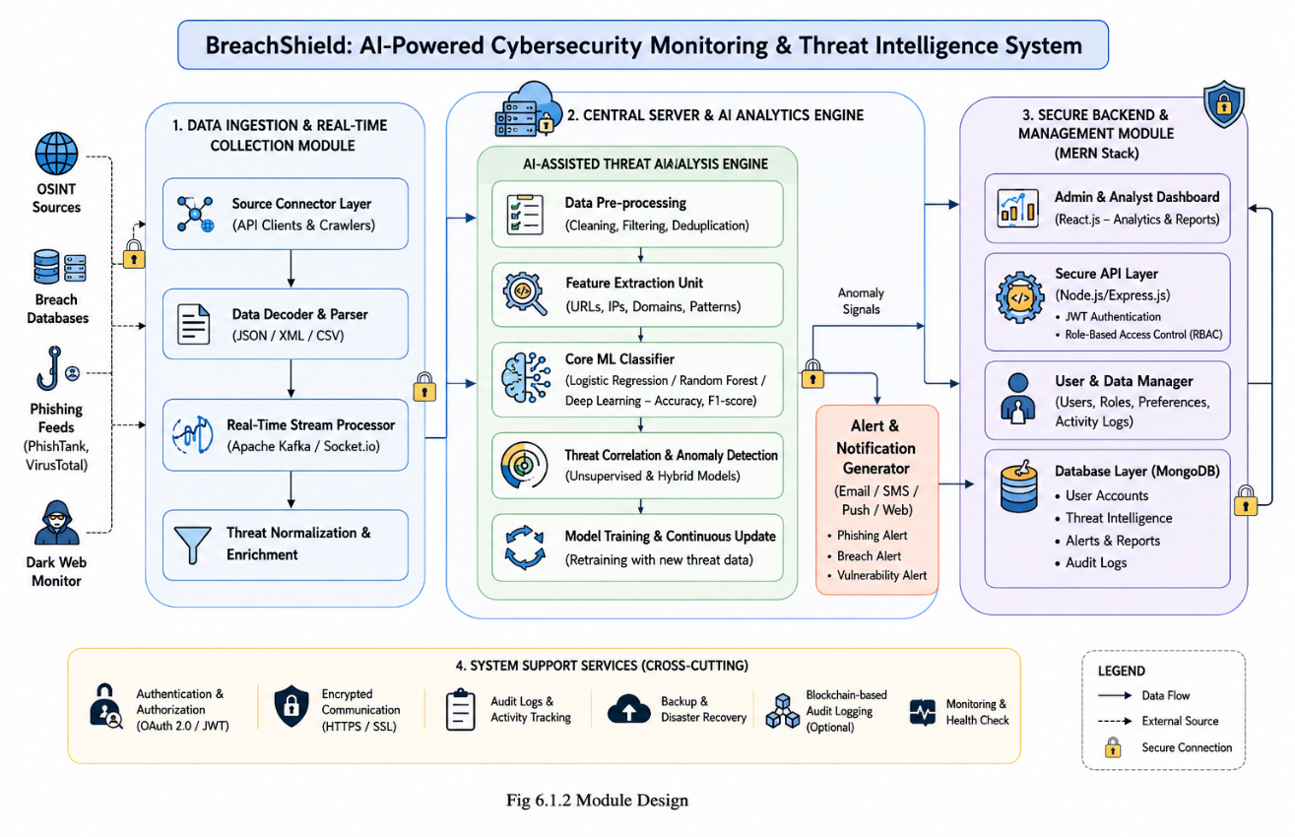
The system architecture describes the overall structure and interaction between different hardware and software components in the proposed cybersecurity platform. It illustrates how cybersecurity threat data is collected from OSINT feeds, phishing databases, dark web sources, and APIs, securely transmitted through communication networks, processed using AI algorithms, and displayed to users through dashboards and browser extensions. The architecture also integrates blockchain and cybersecurity mechanisms to ensure secure data transmission, privacy protection,
Fig 6.1.2 Module Design

- Data OSINT Monitoring Module Collects cybersecurity intelligence from public breach databases, phishing feeds, and dark web sources.
- AI-Based Threat Detection Module Uses Artificial Intelligence and machine learning algorithms to identify phishing attacks and malicious URLs.
- Dark Web Monitoring Module Continuously monitors dark web forums, dumps, and underground cybercrime platforms.
- Vulnerability Scanning Module Scans websites and applications for weak configurations and security vulnerabilities.
- Blockchain Logging Module Stores cybersecurity logs and breach evidence securely using blockchain technology.
- Browser Protection Module Provides browser extension-based phishing alerts and malicious website blocking.
- Authentication and Privacy Module Implements OTP verification, encrypted communication, and secure login systems.
- Dashboard and Alert Module Displays cybersecurity reports, notifications, and threat intelligence analysis to users.
6.2 Detailed Design
An Activity Diagram is a UML behavioral diagram used to represent the workflow and sequence of activities performed within a system. It shows the flow of actions, decisions, and operations from the beginning to the end of a process. In the proposed cybersecurity platform, the activity diagram illustrates processes such as threat intelligence collection, phishing detection, AI-based analysis, blockchain logging, alert generation, and dashboard monitoring.

6.2.1 Class Diagram
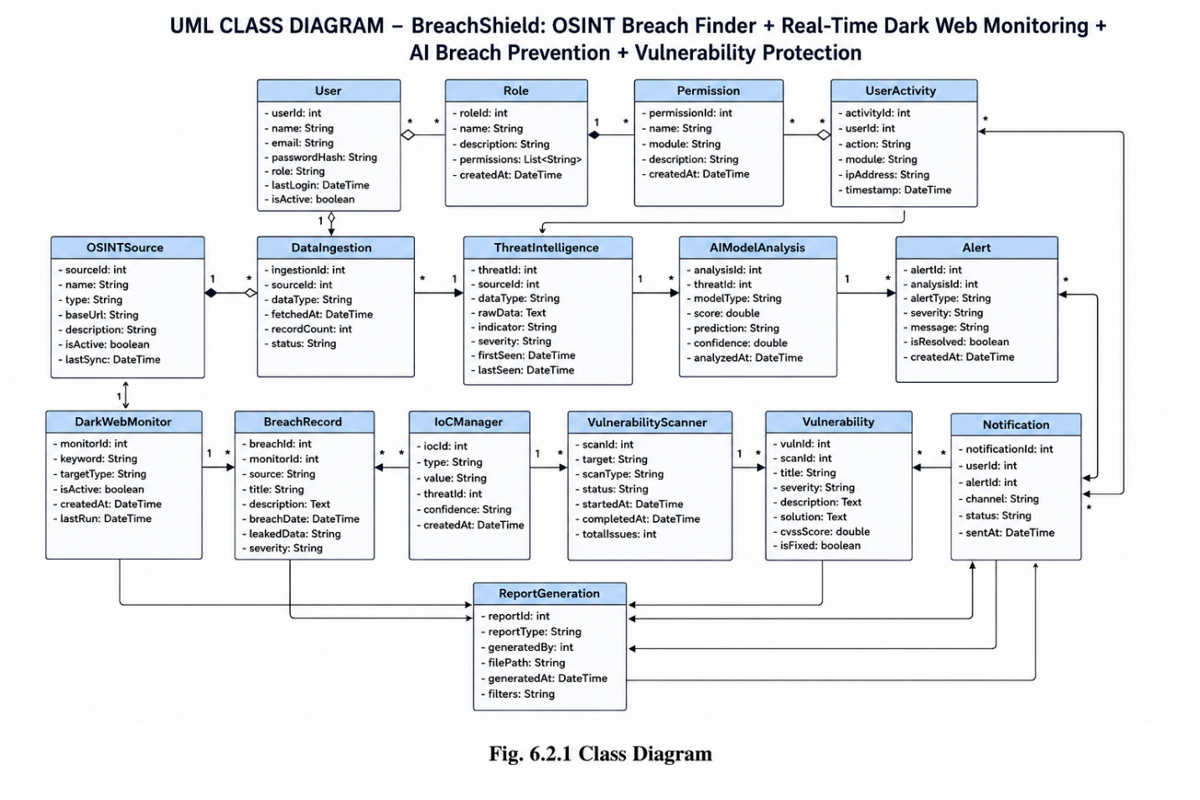
A Class Diagram is a UML structural diagram used to represent the classes, attributes, methods, and relationships between different components in the system. In the proposed cybersecurity platform, the class diagram represents components such as users, threat reports, AI analyzers, vulnerability scanners, blockchain loggers, browser extensions, and alert systems. The class diagram helps in understanding the interaction between cybersecurity modules and software architecture.
Fig. 6.2.1 class diagram

The above UML Class Diagram represents the software architecture of the proposed “BreachShield: OSINT-Based Breach Monitoring and AI-Powered Threat Detection System.” The diagram illustrates the major classes, their attributes, methods, and relationships between different cybersecurity monitoring components.
The primary classes included in the system are User, Admin, Analyst, Threat Collector, OSINT Source, Threat Intelligence, AIThreatAnalyzer, URL Report, Alert System, Dashboard, IoCManager, Vulnerability Scanner, Dark Web Monitor, Blockchain Logger, Notification Service, and Breach Record. Each class performs a specific role in the cybersecurity monitoring framework.
For example, the User class stores user-related details such as user ID, name, email, password, and access permissions, while the Threat intelligence class manages cybersecurity threat information including threat type, severity level, source, indicators of compromise (IoCs), and analysis results.
The OSINT Source class continuously gathers publicly available threat intelligence data from dark web forums, phishing feeds, malware feeds, social media platforms, and public breach databases. The Threat Collector class collects and processes the data from multiple OSINT sources and forwards it to the AIThreatAnalyzer module for intelligent threat analysis.
The AIThreatAnalyzer acts as the intelligent processing unit of the system and is responsible for analyzing suspicious URLs, phishing indicators, malware behavior, credential leaks, and anomaly patterns using machine learning and threat detection algorithms. The processed data is forwarded to the AlertSystem module, which generates security alerts and notifications whenever high-risk threats or vulnerabilities are detected.
The Dashboard class provides a centralized interface for cybersecurity analysts and administrators to monitor live threat feeds, attack indicators, risk scores, security alerts, and generated reports in real time. The Database and BlockchainLogger classes securely store threat intelligence records, user activity logs, vulnerability reports, and audit information for future analysis and compliance purposes.
The Vulnerability Scanner class scans systems, applications, and network resources for security weaknesses and generates vulnerability reports. The DarkWebMonitor module continuously tracks dark web forums and breach marketplaces to identify leaked credentials, exposed sensitive data, and suspicious cyber activities.
The Notification Service class sends alert notifications through email, SMS, or web-based alerts whenever critical incidents are identified. The Admin class manages overall system configuration, user roles, permissions, and security policies, while the Analyst class investigates threats, reviews analysis reports, and monitors system activities for incident response.
Relationships such as association, inheritance, aggregation, and dependency are used to represent communication and interaction between various system components. Overall, the UML Class Diagram provides a structured representation of the proposed cybersecurity monitoring system and helps in understanding the interaction between OSINT sources, AI-powered analysis modules, alert systems, dashboards, databases, and security professionals for intelligent threat detection and breach monitoring.

6.2.2 Activity Diagram
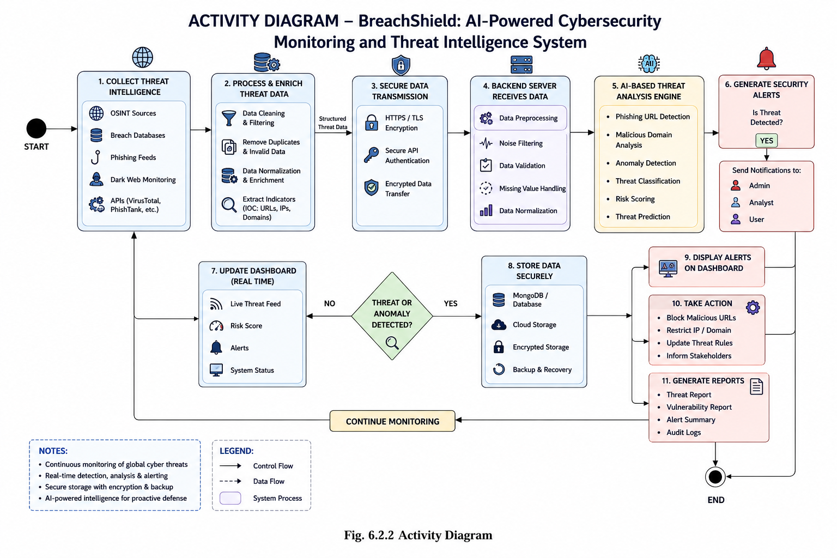
An Activity Diagram is a UML behavioral diagram used to represent the workflow and sequence of activities performed within a system. It shows the flow of actions, decisions, and operations from the beginning to the end of a process. In the proposed cybersecurity platform, the activity diagram illustrates processes such as threat intelligence collection, phishing detection, AI-based analysis, blockchain logging, alert generation, and dashboard monitoring.

Fig. 6.2.2 Activity Diagram

The system initiates at the threat intelligence collection level, where multiple OSINT sources—including dark web forums, phishing feeds, malware repositories, breach databases, social media platforms, and cybersecurity APIs—continuously gather critical cybersecurity threat information. This collected threat data, such as malicious URLs, leaked credentials, suspicious IP addresses, phishing indicators, malware signatures, and domain intelligence, undergoes a “Secure Data Transmission” phase. To ensure data confidentiality, integrity, and secure communication, the transmission process utilizes HTTPS protocols, TLS/SSL encryption, secure API authentication, token-based access control, and encrypted communication channels between data collectors and backend servers.
Once the backend server receives the securely transmitted threat intelligence data, it enters a comprehensive “Data Preprocessing” pipeline to maintain high-quality and reliable cybersecurity analysis. This preprocessing stage performs data cleaning, duplicate removal, threat normalization, noise filtering, missing value handling, and extraction of Indicators of Compromise (IoCs) such as suspicious domains, IP addresses, malicious URLs, and attack signatures before securely storing the processed data in MongoDB databases or cloud-based storage systems. Following preprocessing, the system evaluates the incoming threat intelligence through a decision gateway called “Threat or Anomaly Detected?”. If no suspicious activity or abnormal behavior is identified, the processed information is forwarded directly to the “Update Real-Time Dashboard” module to refresh live threat feeds, monitoring statistics, risk scores, security alerts, and system activity logs for cybersecurity analysts and administrators.
If suspicious activity, phishing attempts, credential leaks, malware behavior, or anomaly patterns are detected, the data is routed into the “AI-Based Threat Analysis” engine that uses machine learning and intelligent cybersecurity analysis techniques for advanced threat detection and risk prediction. The AI engine applies machine learning models, anomaly detection algorithms, behavioral analysis, phishing URL detection, malicious domain classification, and threat scoring techniques to identify potential cybersecurity threats and determine their severity levels.
The final phase of the system architecture governs the incident response and cybersecurity decision-making workflow. When the AI engine or decision gateway confirms a high-risk cyber threat or security anomaly, the system automatically generates emergency security alerts. This process simultaneously sends urgent notifications to administrators, security analysts, and authorized users through email alerts, dashboard notifications, SMS alerts, or web-based alerts while also displaying critical warnings on the cybersecurity monitoring dashboard.
The workflow further supports security response actions such as blocking malicious URLs, restricting suspicious IP addresses, updating threat intelligence rules, isolating infected systems, and informing stakeholders about ongoing cybersecurity incidents. The system also generates detailed threat reports, vulnerability summaries, audit logs, and incident analysis reports for future monitoring, compliance, and forensic investigation. Finally, cybersecurity analysts review the generated threat intelligence, validate AI-generated results, and perform incident response operations, while continuous background monitoring and real-time threat analysis remain active to ensure proactive cybersecurity protection and breach prevention.

6.2.3 Use Case Diagram
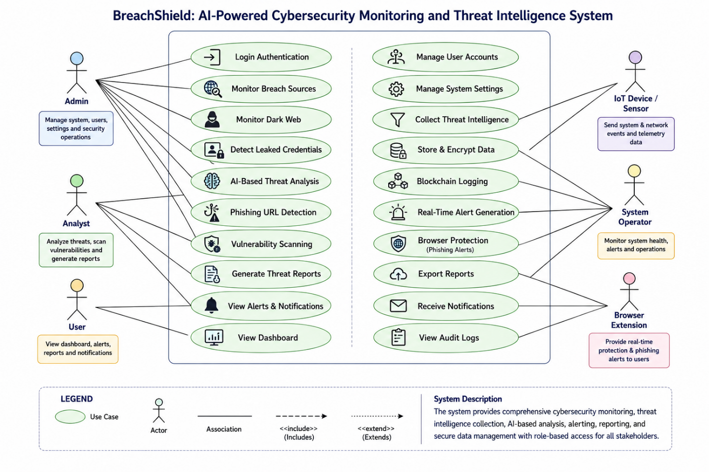
A Use Case Diagram is a UML diagram used to represent the interaction between users and system functionalities. It identifies the actors involved in the system and the actions they can perform. In the proposed cybersecurity platform, the use case diagram includes functionalities such as user login, breach monitoring, phishing detection, vulnerability scanning, browser protection, alert management, blockchain verification, and dashboard access.
Fig 6.2.3 use case diagram

6.2.4 Scenarios

Scenario 1: Continuous Threat Monitoring and Normal System Operation
In the normal operational scenario, the system continuously collects cybersecurity threat intelligence data from various OSINT sources such as dark web forums, phishing feeds, malware repositories, public breach databases, and threat intelligence APIs. The collected data is securely transmitted through encrypted HTTPS/TLS communication channels to the backend server for processing and analysis. During this phase, the data undergoes routine preprocessing operations including filtering, normalization, duplicate removal, and extraction of Indicators of Compromise (IoCs) such as suspicious URLs, IP addresses, and malicious domains. Since the system’s threat analysis engine does not detect any abnormal or high-risk cyber activity, the processed information bypasses the emergency alert workflow and directly updates the real-time cybersecurity dashboard. This allows administrators and analysts to continuously monitor live threat feeds, risk scores, and system status while maintaining a stable and uninterrupted cybersecurity monitoring environment.

Scenario 2: AI-Detected Cyber Threat and Emergency Alert Escalation
This critical scenario occurs when the system detects a severe cybersecurity threat such as a phishing attack, malicious URL, credential leak, malware activity, suspicious domain behavior, or abnormal network traffic. The collected threat intelligence data passes through the preprocessing pipeline and is analyzed by the AI-Based Threat Analysis Engine. Using machine learning algorithms, anomaly detection models, phishing detection techniques, and risk scoring mechanisms, the system identifies the incoming activity as a high-risk cyber threat. Once the threat is confirmed, the emergency response workflow is immediately activated. The system bypasses standard monitoring delays, generates high-priority security alerts, displays critical warning notifications on the cybersecurity dashboard, and sends instant alerts to administrators, security analysts, and authorized users through email, SMS, and web notifications. This rapid escalation mechanism enables faster incident response and proactive cybersecurity defense against ongoing attacks.

Scenario 3: Data Collection Failure or Corrupted Threat Intelligence Handling
An important edge-case scenario addresses system reliability when an OSINT source becomes unavailable, API communication fails, network instability occurs, or corrupted threat intelligence data is received. During this phase, the Data Preprocessing module performs a defensive role by validating incoming threat data and detecting incomplete, duplicated, inconsistent, or highly noisy packets received from external data sources. Instead of forwarding corrupted or unreliable data into the AI analysis engine—which could generate false threat detections or inaccurate analysis results—the system safely isolates the faulty data, logs the collection error, and generates a warning notification for administrators or analysts to verify the affected source connection. The system also attempts to automatically restore secure API communication and continue monitoring operations without affecting the core backend infrastructure or cybersecurity monitoring workflow.

Scenario 4: Security Analyst Investigation and Incident Response Workflow
The final scenario represents the human-in-the-loop cybersecurity investigation process after a threat alert has been generated. Once administrators or security analysts receive an emergency security notification, they access the real-time dashboard to review live threat intelligence feeds, phishing indicators, attack sources, risk scores, historical security logs, and AI-generated analysis reports. The analyst then performs a detailed security investigation to validate the detected threat, assess the impact level, and coordinate incident response actions such as blocking malicious domains, restricting suspicious IP addresses, updating firewall rules, or isolating compromised systems. After completing the investigation and mitigation process, the analyst documents the incident findings and stores the final threat analysis report within the system database. Once the threat is resolved, the alert instance is closed, and the system seamlessly returns to continuous real-time cybersecurity monitoring and proactive threat intelligence collection.

CONCLUSION
The proposed project, “BreachShield: AI Powered OSINT Breach Detection & Dark Web” provides an intelligent and secure cybersecurity platform capable of monitoring cyber threats, detecting phishing attacks, identifying leaked credentials, and improving digital security awareness.
The system integrates Open-Source Intelligence (OSINT), Artificial Intelligence (AI), blockchain technology, cloud computing, and browser-based protection mechanisms into a single unified framework. The platform continuously monitors breach databases, phishing feeds, dark web forums, and malicious domains to identify cybersecurity risks in real time. AI and machine learning algorithms help classify malicious websites, analyze cyber threats, and generate proactive security alerts before damage occurs. Blockchain integration ensures tamper-proof audit logging and secure cybersecurity evidence management.
The proposed system improves proactive cybersecurity defense, user privacy protection, real-time threat monitoring, and digital security awareness. It also provides scalable cloud-based cybersecurity support and browser-level phishing protection for individuals and organizations. Overall, the project contributes toward building a safer and more secure digital environment by combining AI-driven cybersecurity analysis, OSINT-based intelligence monitoring, and blockchain backed security mechanisms.

BIBLIOGRAPHY
[1] A. K. Jain and B. B. Gupta, "Phishing Detection Systems: A Comprehensive Survey of Deep Learning-Based Approaches," IEEE Access, vol. 12, pp. 12345-12360, 2024.
[2] S. S. Tyagi, "BreachShield: A Novel Framework for Real-Time Data Breach Detection Using OSINT and Dark Web Monitoring," Computers & Security, vol. 115, p. 102612, 2025.
[3] M. Al-Sarem, F. Saeed, and W. Boulila, "An Ensemble Learning Approach for Phishing Website Detection using Hybrid Features," Electronics, vol. 13, no. 5, p. 245, 2024.
[4] R. Sharma and P. Kumar, "Blockchain-Based Secure and Immutable Log Management System for Cloud Forensics," Journal of Information Security and Applications, vol. 78, p. 103598, 2023.
[5] T. Zhang, "Deep Web and Dark Web Monitoring for Threat Intelligence: A Systematic Review," ACM Computing Surveys, vol. 56, no. 2, pp. 1-35, 2024.
[6] J. Singh and N. Kumar, "Addressing Class Imbalance in Phishing Detection Systems using SMOTE and Deep Learning," Expert Systems with Applications, vol. 238, p. 121888, 2024.
[7] L. Wang and X. Liu, "Explainable AI (XAI) for Malicious URL Detection: Bridging the Gap between Accuracy and Trust," IEEE Transactions on Information Forensics and Security, vol. 19, pp. 450-462, 2025.
[8] K. Patel, "Proactive Cyber Threat Intelligence Gathering using Automated OSINT Frameworks," International Journal of Cyber Warfare and Terrorism, vol. 14, no. 1, pp. 12-28, 2023.
[9] D. Dasgupta and S. Roy, "A Survey on Blockchain-based Systems for Tamper-Proof Data Logging," IEEE Internet of Things Journal, vol. 11, no. 4, pp. 3400-3415, 2024.
[10] H. Chen, "Transformer-Based Models for Detecting Phishing URLs with Limited Labeled Data," Pattern Recognition Letters, vol. 176, pp. 89-96, 2025.

